**Creating a Consortium in Kaleido**

*Initial Note:*

*The blockchain digital environment is a very dynamic environment where updates and changes occur frequently. In this program, to carry out the practical activities and give you a real vision of the tools available on the market, web resources and software external to this program are used.*

*For this reason, although we make every effort to keep the guides updated, sometimes the appearance you see of the tools may be different from the images we show you in this guide and its accompanying documents. Don't worry about the differences you may find. In most cases you will be able to follow the instructions of the activity by easily interpreting the differences between the guide and the real environment, if any. In the case of this not being possible, please let your facilitator know by sending a message through the inbox of the program's platform. The facilitator will help you resolve any questions you may have.*

# **1.- Introduction:**

This walkthrough will indicate the options that will allow you to create a simple blockchain network selecting the available options on the Kaleido platform. In the process, additionally, you will see other available options on the platform that, by simply selecting them, allow you to create blockchain consortia of considerable complexity.

The walkthrough also shows you how to deploy a contract, such as, on the network that you are going to create and how to make use of the basic functions in that contract.

All of the above is a sample of the simplicity and potential of platforms such as Kaleido that, being based on Cloud technology, make easy access, construction, maintenance and use, available to the users of Blockchain technology as an online service (BaaS – Blockchain as a Service).

# **2.- Creating a Consortium, deploying and testing a contract:**

Access Kaleido through the following link: [www.kaleido.io](http://www.kaleido.io) and select the option Try it Free .

*Img. 1: Kaleido’s landing page*

Enter your email address and a password, and then select a base location for your consortium. This location doesn’t necessarily need to be your country of residence. If you are unable to find your country or place or residence in this list, you may select another one of your preference.

|  |  |
| --- | --- |
|  |  |

*Img. 2: Creating a new account*

*Img. 3: Select your location*

You may also use your Google account to validate your Kaleido account. Next, you will be asked for a confirmation code and some personal details.

|  |  |
| --- | --- |
|  |  |

*Img. 4: Account details Img. 5: Company and user details*

On the next page, you must select a subscription plan. To start, select the “Starter” free plan. Select it by clicking the SELECT button.

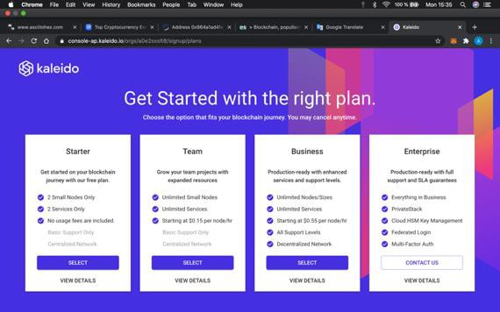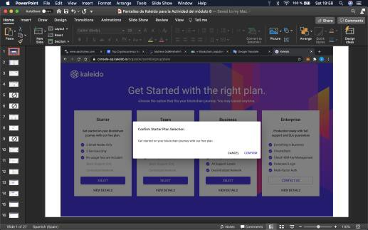

*Img. 6: Selecting the “Starter” plan Img. 7: Confirming plan selection*

The consortium creation process begins by creating the blockchain network on which the consortium will operate. Close the What’s New! Window and click on the CREATE NETWORK button in the center of the screen.

|  |  |
| --- | --- |
|  |  |

*Img. 8: Closing “What’s New!” Img. 9: Creating a consortium*

Choose a name for your consortium and add a mission statement. Then, click on the NEXT button to continue.

|  |
| --- |
|   *Img. 10: Consortium name and mission statement* |

Select a home region. Again, this does not need to correspond to your country of residence. Choose whichever one you prefer and continue by clicking on NEXT.

|  |
| --- |
|   *Img. 11: Consortium home region* |

In the next window you will see the message “Additional regions are unavailable on your current plan”. Click on FINISH to continue.

|  |
| --- |
|   *Img. 12: Unavailable additional regions message* |

We can now start defining the characteristics for our consortium operations. To start, Click on CREATE ENVIRONMENT. Select STANDARD BLOCKCHAIN SERVICE and click on NEXT to continue.

|  |  |
| --- | --- |
|  |  |

*Img. 13: Consortium Configuration Img. 14: Standard Blockchain*

We must choose the blockchain protocol to use for our consortium. Select ETHEREUM and click on NEXT to continue,

|  |
| --- |
|   *Img. 15: Ethereum Blockchain protocol* |

Now choose a name for your environment. Select the CLOUD ONLY option and click on NEXT to continue.

|  |
| --- |
|   *Img. 16: Environment name* |

Finally, you will have the option to select provider settings for your environment. Explore all available options. This part of the activity is completed through the default options which are Geth for provider and PoA for the consensus algorithm. Click FINISH to complete the environment setup.

|  |
| --- |
|   *Img. 17: Configuración del Ambiente* |

Once your environment has been created, the next step is to add nodes. Select the ETHEREUM option.

|  |
| --- |
|   *Img. 18: Create node* |

Choose a name for the first node, without modifying the deployment region, and move on to the next section by clicking on NEXT. On the next screen you will see the different configurations that the provider offers. Explore all that are available. When using the “Starter” plan, default conditions will remain when you click on.

|  |  |
| --- | --- |
|  |  |

*Img. 19: Choose node name Img. 20: Configure node*

Finally, you will see the option to define the node size for the provider. Explore all available options. Select the default option and click NEXT to finish creating your node.

|  |
| --- |
|   *Img. 21: Node size* |

You will notice that Kaleido has created a node with all the settings you selected. Wait until the node’s status changes to STARTED. Place your cursor over the name of your node on the vertical menu to the left of the screen until the ADD NODE option appears.

|  |
| --- |
|   *Img. 22: Node overview* |

Once you have finished adding your second node, choose the **DASHBOARD** option on the vertical menu to the left side of your screen, where your consortium should look similar to the following image:

|  |
| --- |
|   *Img. 23: Main dashboard with 2 existing nodes* |

You may now observe that, on top of the nodes that you have just created, Kaleido has added a node called: “System Monitor”, which will allow you to monitor your blockchain.

# **3.- Monitoring blocks, contracts, transactions, …**

On the DASHBOARD view for your consortium found on the vertical menu, select the options: Data Explorer -> Block Explorer -> Dashboard. There, on the first horizontal menu, you may observe the last mined block, followed by the mining frequency for each block, as well as the number of transactions on the last block and total number of transactions. On the bottom part you will find two sections: the last mined blocks and most recent transactions.

|  |
| --- |
|   *Img. 24: Data explorer* |

Proceed to the “Create a Token in your Kaleido Consortium” guide and then return to the block explorer to perform any necessary searches to answer all assignment questions.